

**Faculty of Engineering & Technology**

**COMPUTER VISION**

**ENCS5343**

**"Assignment 1"**

**Prepared by**: Musab Masalmah

**ID**: 1200078

**Instructor's Name**: Dr. Aziz Qaroush

**Section**: 1

**Date**: 14-12-2023

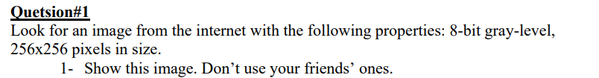

**The Code:**

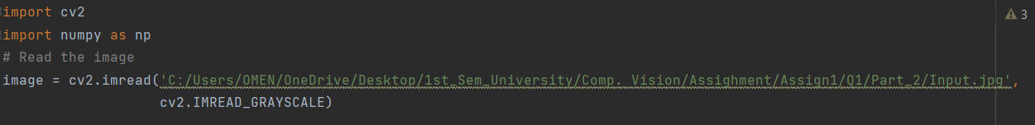

**The Output:**

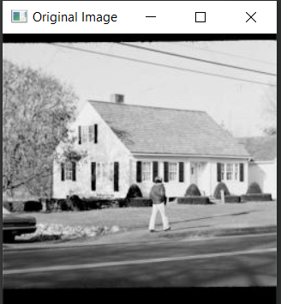



**The code:**

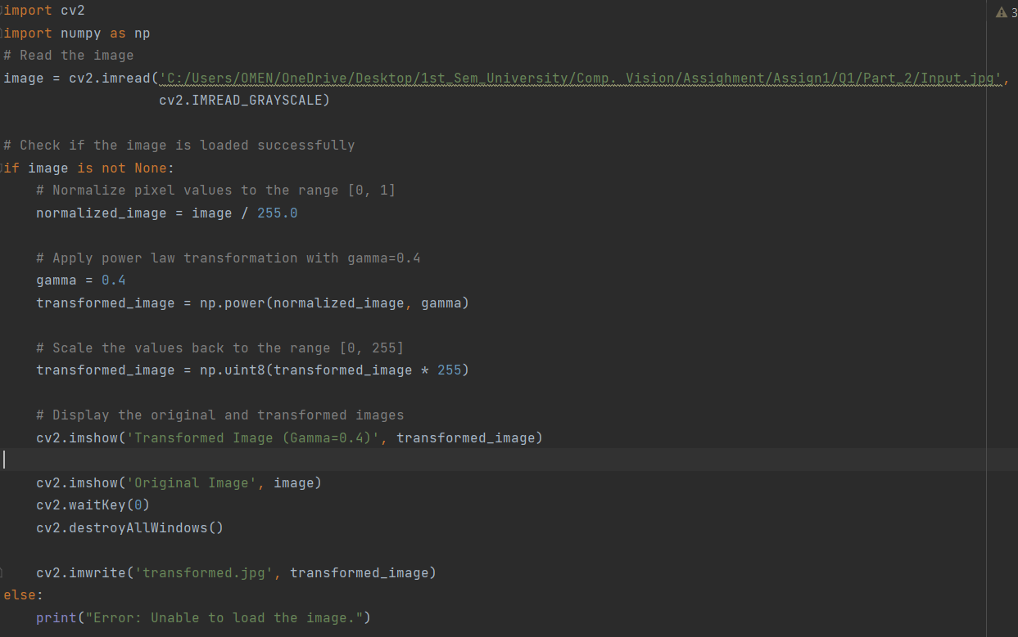

**As we see in the code that**

* **(normalized_image = image / 255.0 ): that Normalize pixel values to the range [0, 1].**
* **(transformed_image = np.power(normalized_image, gamma)): this line Apply power law transformation with gamma=0.4 .**
* **(transformed_image = np.uint8(transformed_image * 255)): this line Scale the values back to the range [0, 255]**

**The Output:**

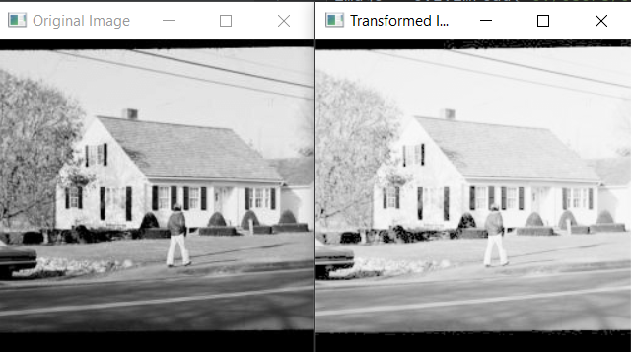



**The code:**

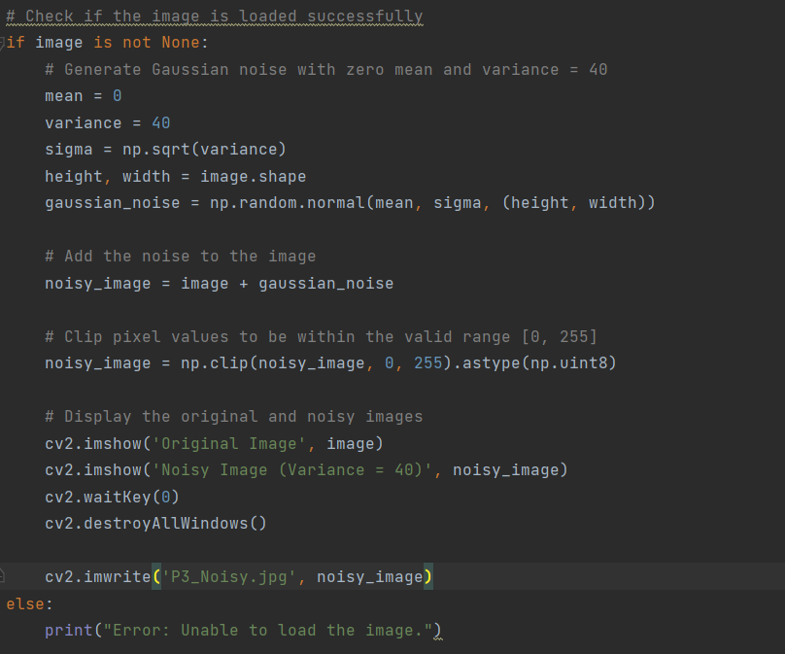

**As we see in the code:**

* (mean = 0  
  variance = 40  
  sigma = np.sqrt(variance)  
  height, width = image.shape  
  gaussian_noise = np.random.normal(mean, sigma, (height, width)))

: This line initializes the variables **mean**, **variance**, **sigma**, **height**, and **width** in a compact manner.

* (noisy_image = image + gaussian_noise ): Add the noise to the image
* (noisy_image = np.clip(noisy_image, 0, 255).astype(np.uint8)): Clip pixel values to be within the valid range [0, 255]

**The Output:**

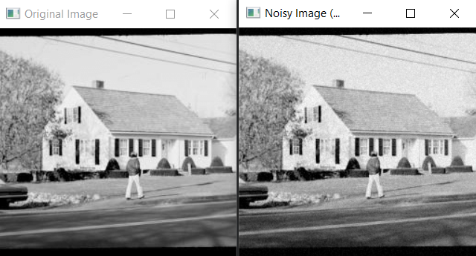



**The code:**

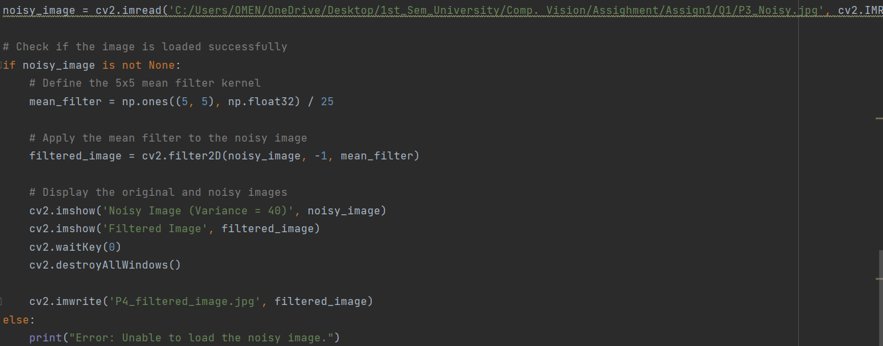

**As we see in the code:**

* **(mean_filter = np.ones((5, 5), np.float32) / 25): Define the 5x5 mean filter kernel**
* **(filtered_image = cv2.filter2D(noisy_image, -1, mean_filter)): Apply the mean filter to the noisy image**

**Output Image:**

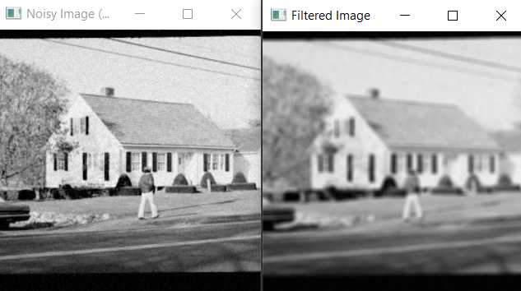

* This filter take the average values of the 25 pixel around the main pixel, that make the main pixel soothe with the around pixels and loss his main value, and that what we see it in the output value.



**The code:**

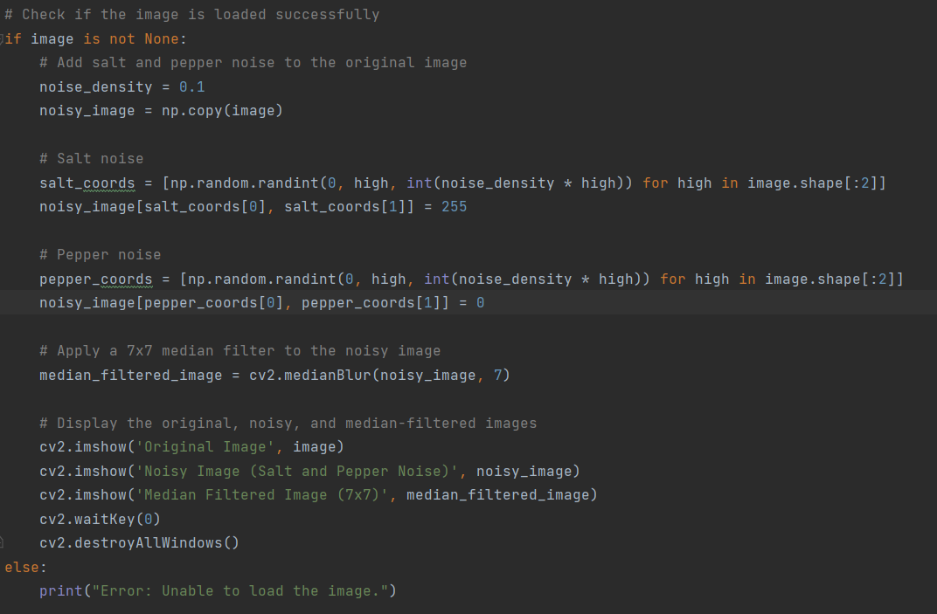

**As we seen in the code:**

* **(salt_coords = [np.random.randint(0, high, int(noise_density * high)) for high in image.shape[:2]]  
  noisy_image[salt_coords[0], salt_coords[1]] = 255  
    
  pepper_coords = [np.random.randint(0, high, int(noise_density * high)) for high in image.shape[:2]]  
  noisy_image[pepper_coords[0], pepper_coords[1]] = 0): put salt and paper randomly in the image.**
* **(median_filtered_image = cv2.medianBlur(noisy_image, 7)): Apply a 7x7 median filter to the noisy image**

**The Output:**

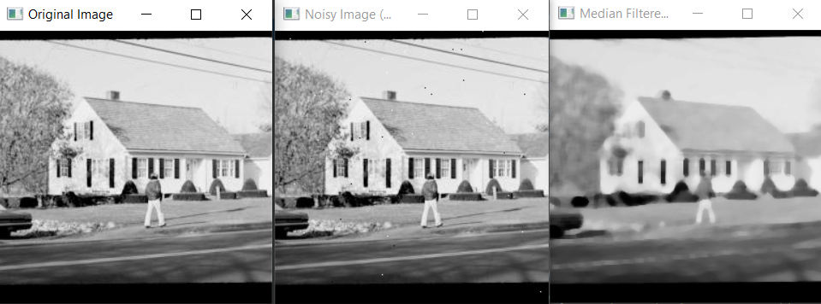



**The code:**

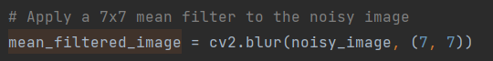

**As the above code in part 5 but I add the mean filter code line.**

**The Output:**

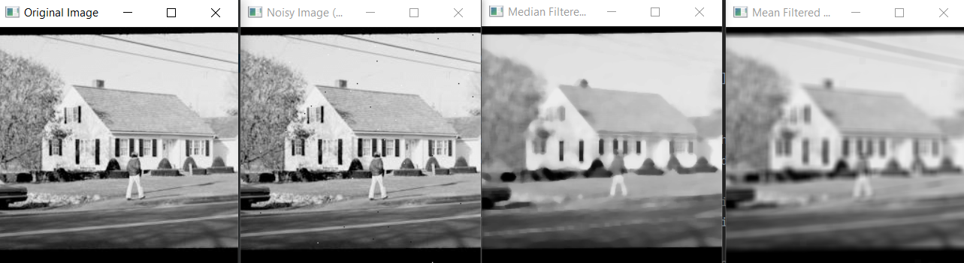

**As we see the both filters remove the salt and paper but the median Preserves edges and details better than mean filters, and the mean filter make the image more smoothing.**



**The code:**

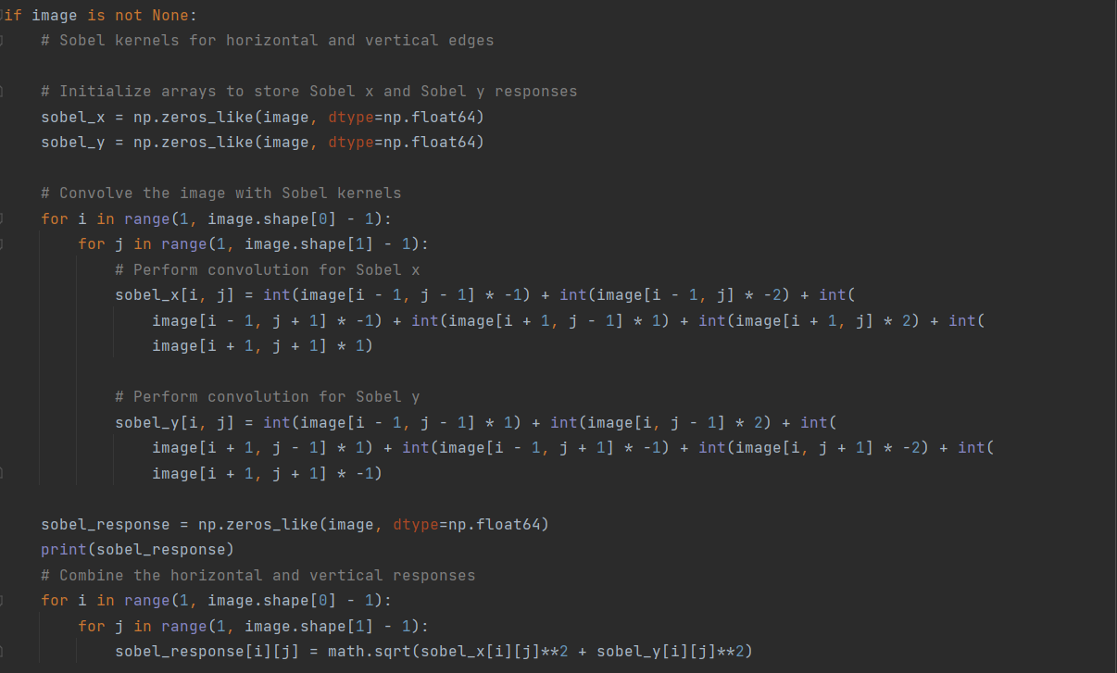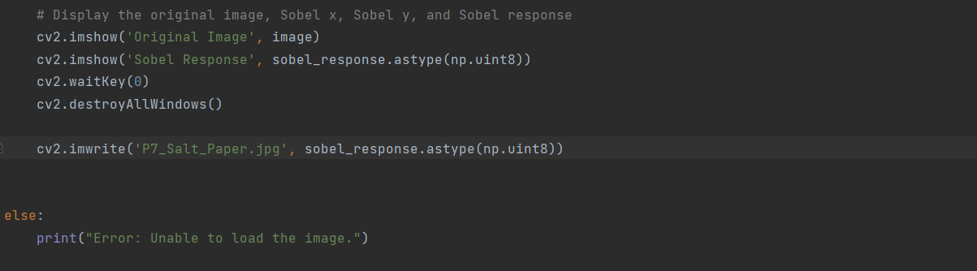

**As we see in the code:**

* 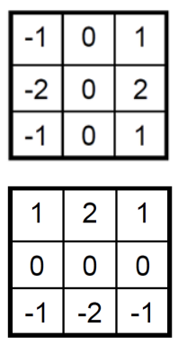**I use these two kernels and multiply all the values in array and then add the values then take the square root of the square of the two values sum.**
* **I use (**np.uint8**) : This conversion ensures that pixel values are within the valid range for image display.**

**The Output:**

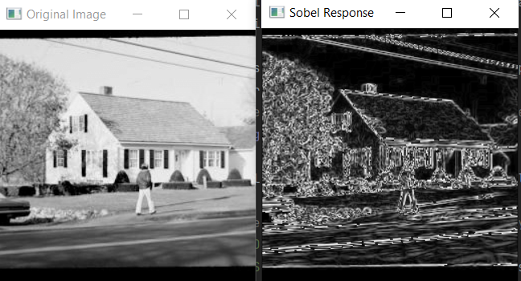

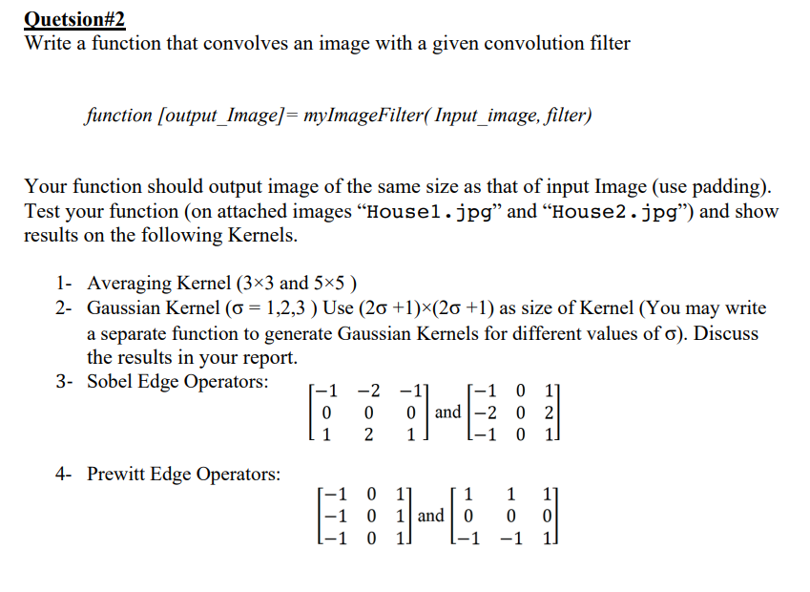

**The code:** 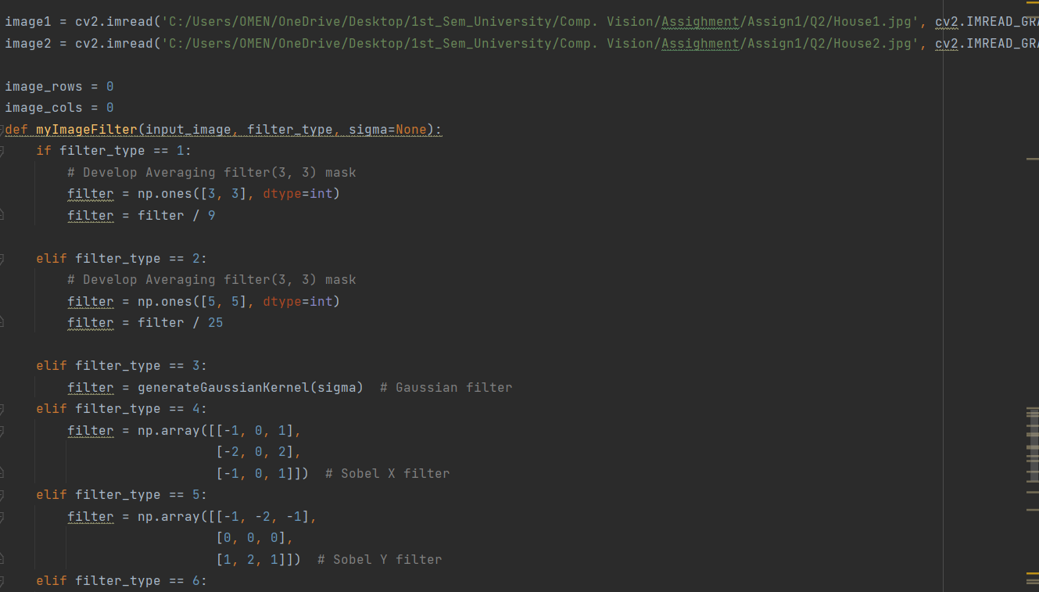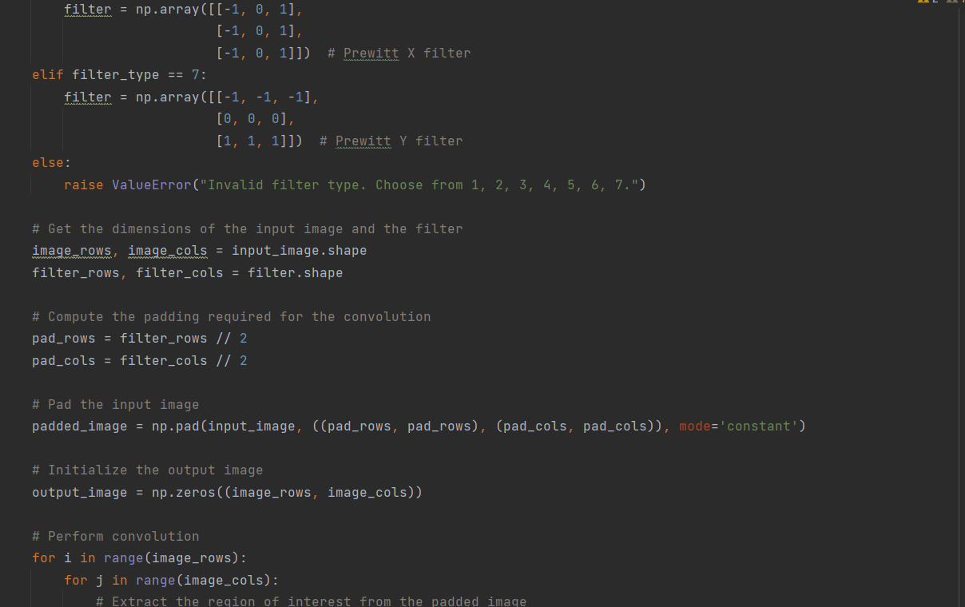

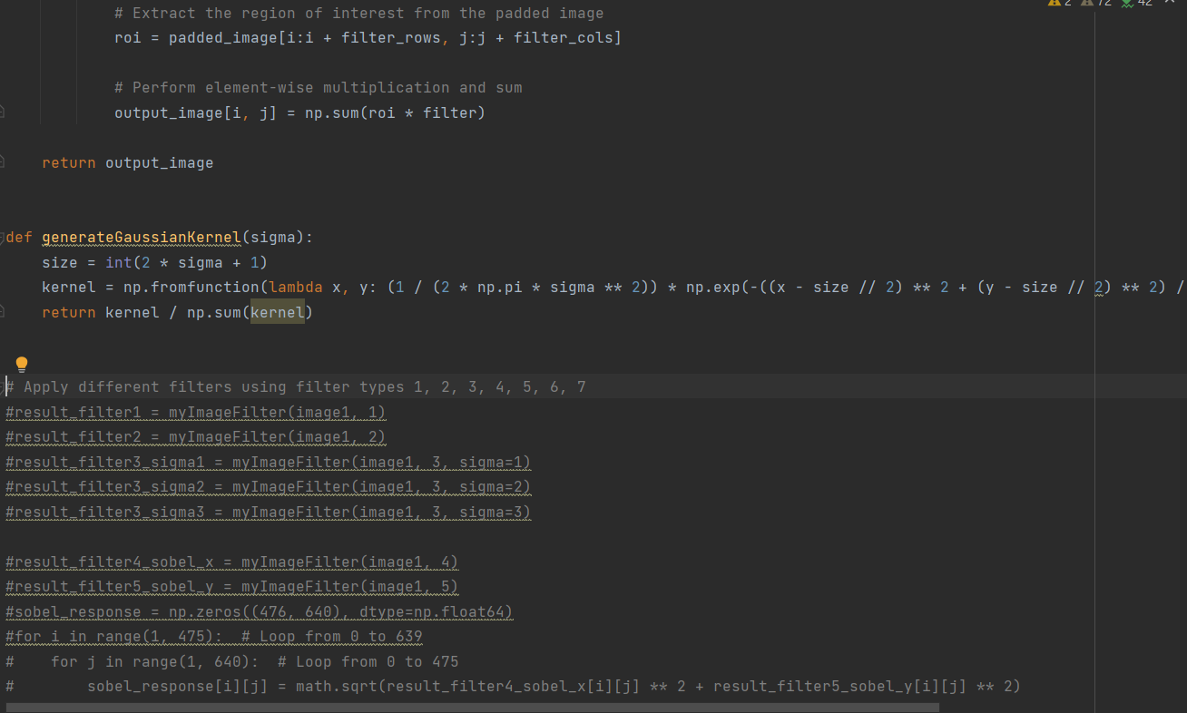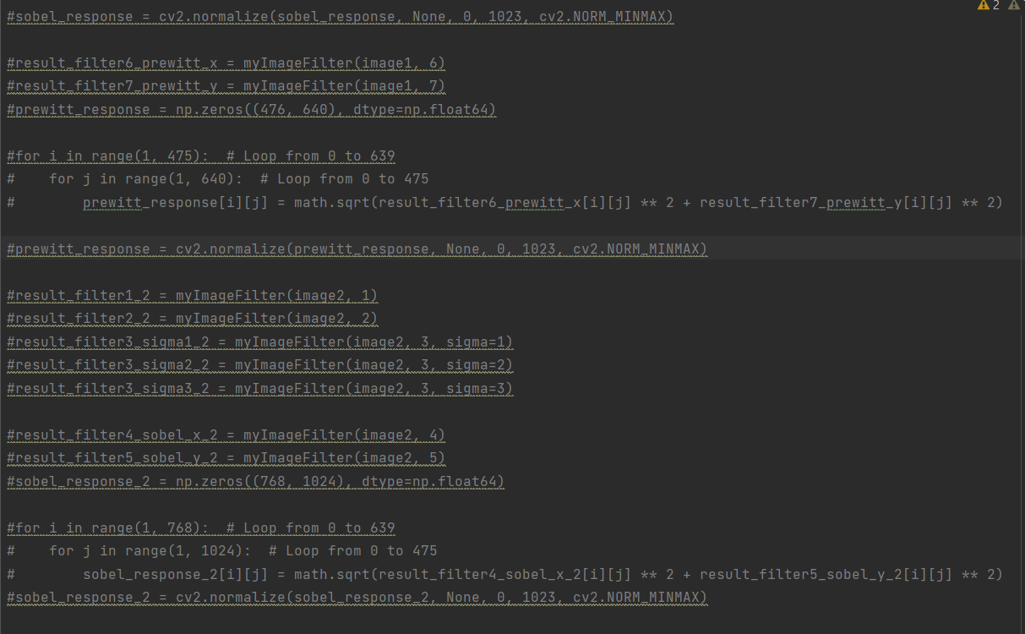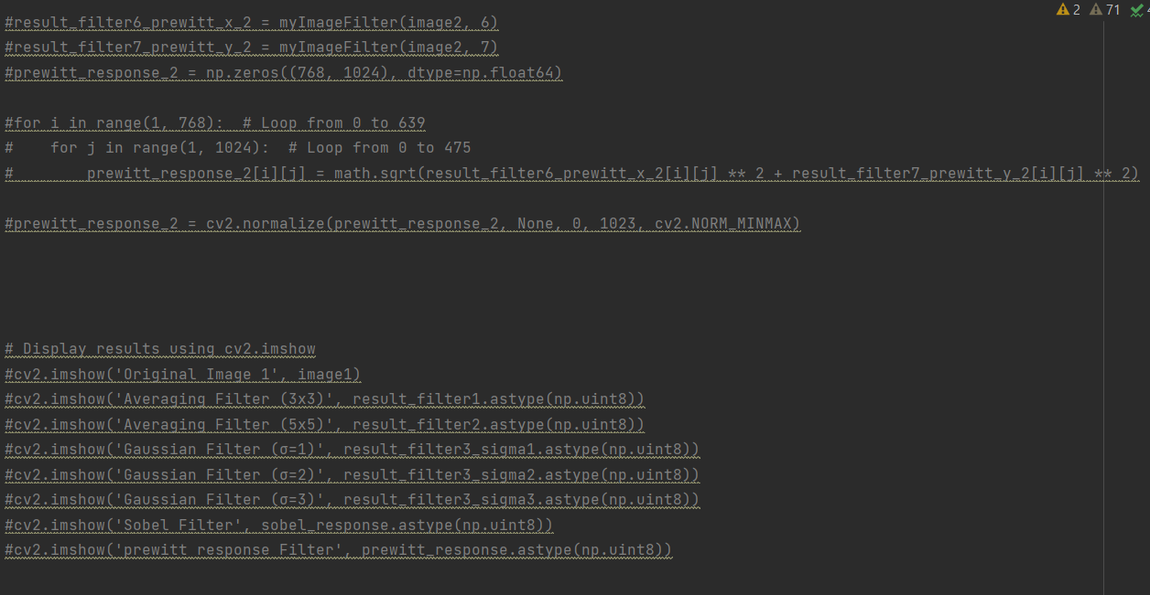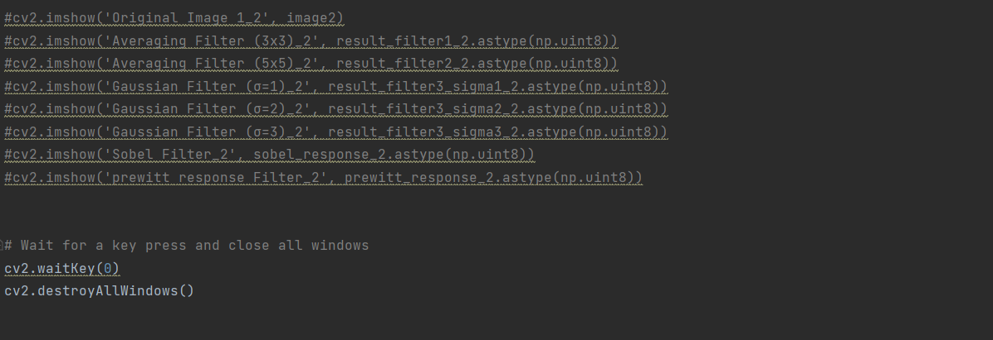

**As we see in the above code:**

* **I have a function and in the first lines of the function detect the filter content:**

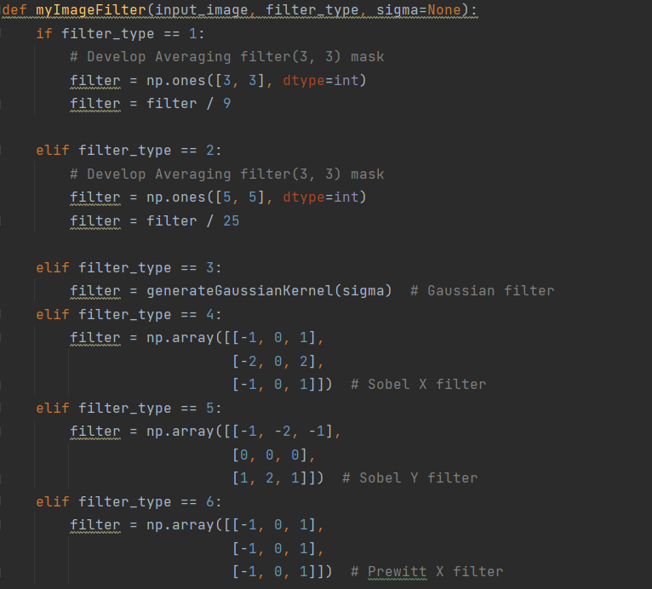

* **And then I make a padding to the image and to the filter:**

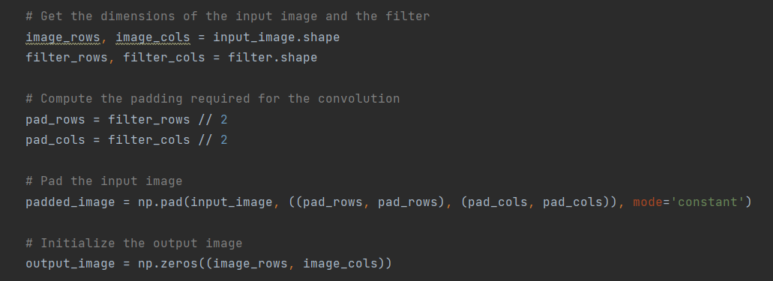

* **And then I do convolution to the chosen filter with the image and return the output:**

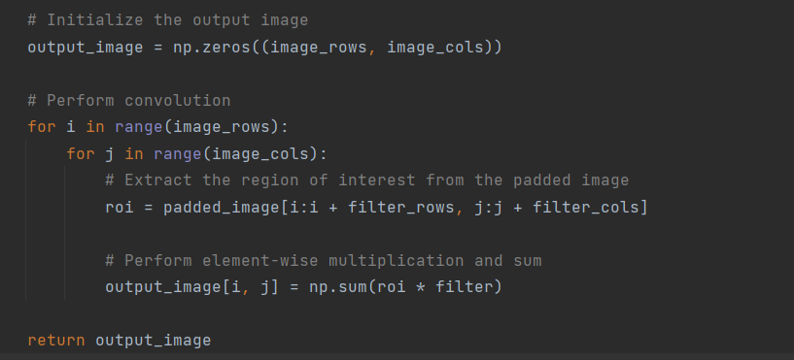

* **Then I generate a Gaussian kernel that I use it in the Gaussian filter:**

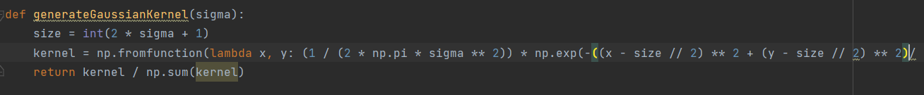

* **Then I start to show images as you see in the code above (The Output):**

**Part1_House1_Avarge Filter (3x3) and (5x5):**

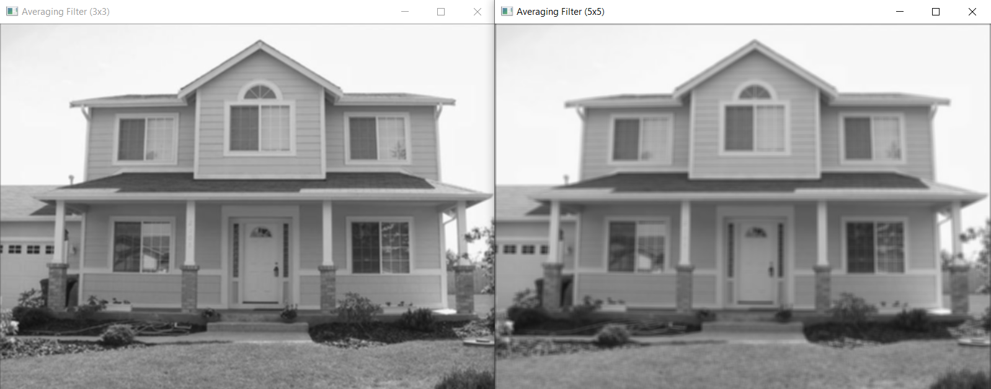

**Part1_House2_Avarge Filter (3x3) and (5x5):**

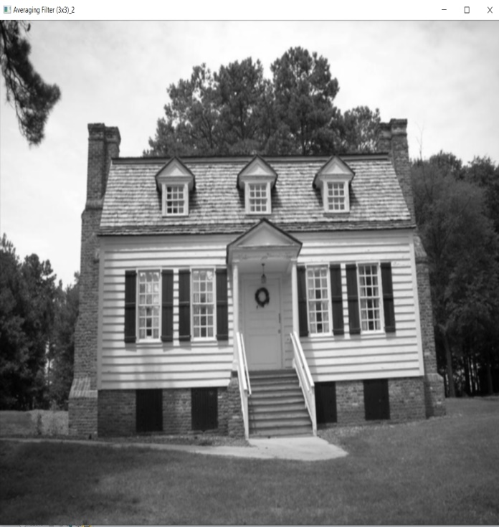

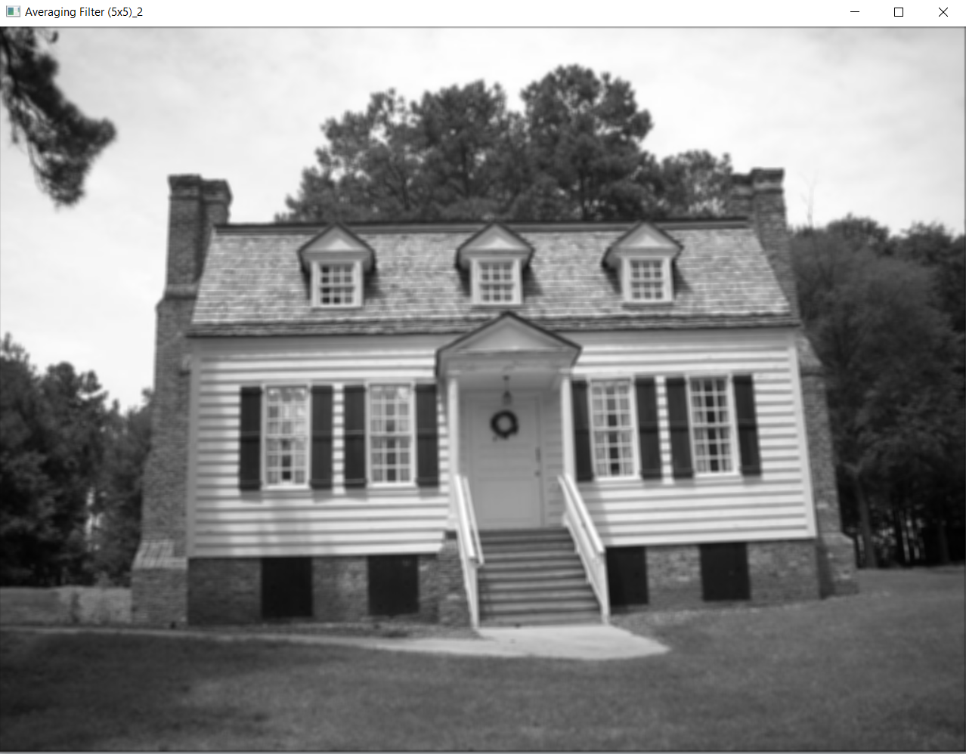

* As we see that when the average filter kernel be bigger that will make the details loss in image.

**Part2_House1_Gaussian Filter Segma = 1 ,2 ,3 :**

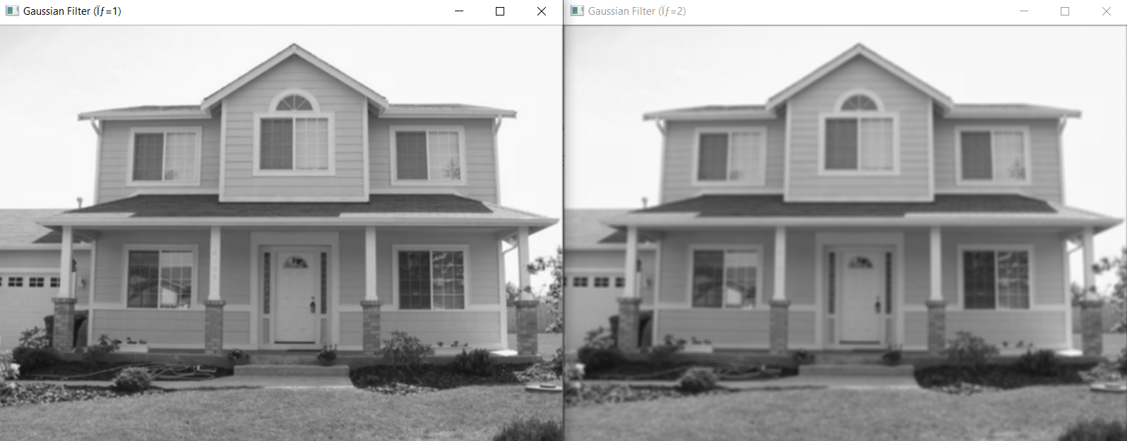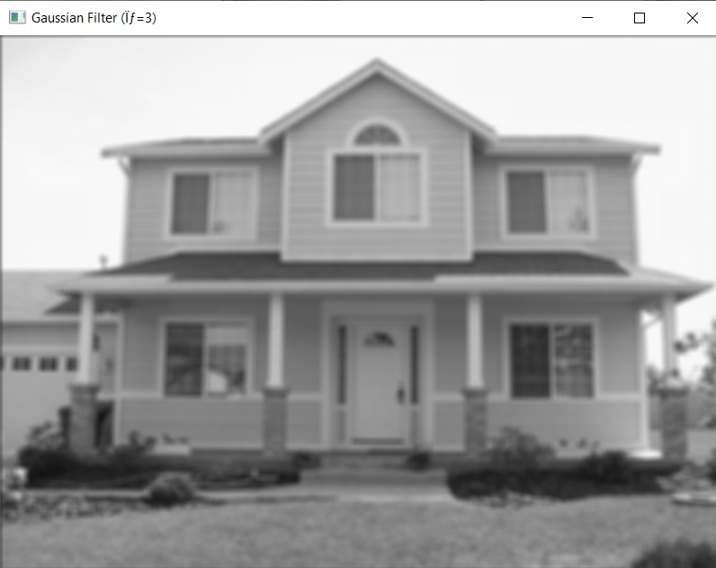

**Part2_House2_Gaussian Filter Segma = 1 ,2 ,3 :**

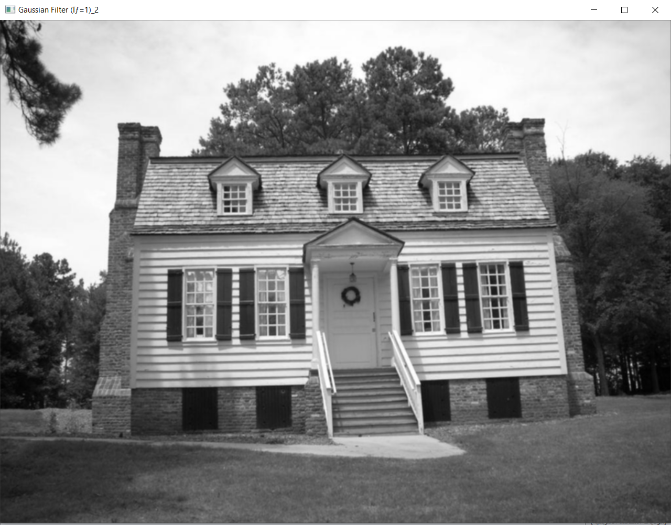 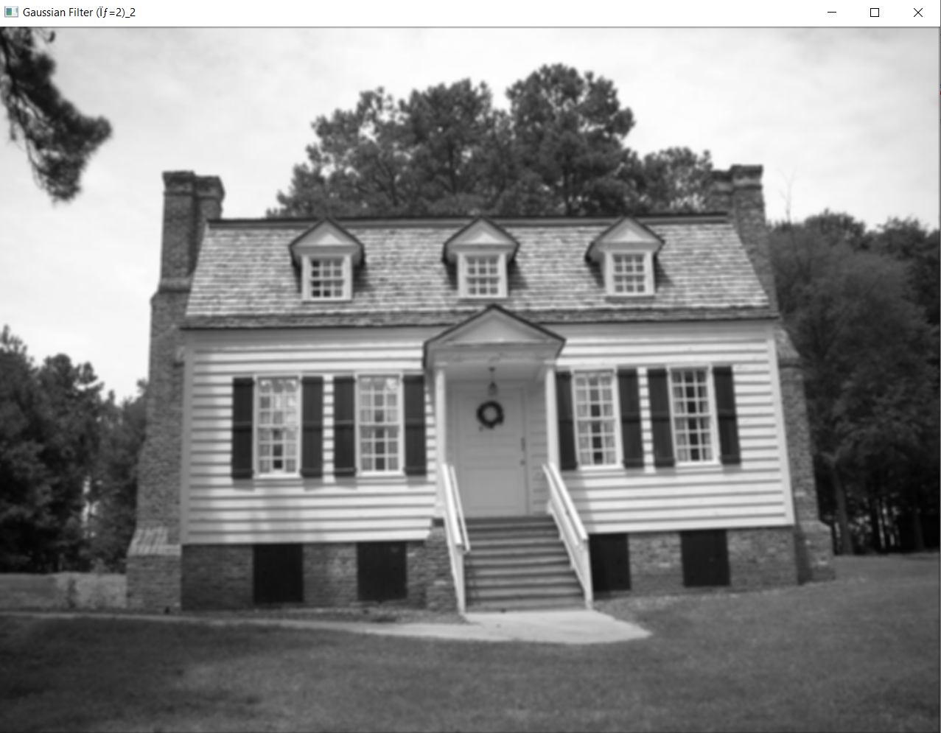

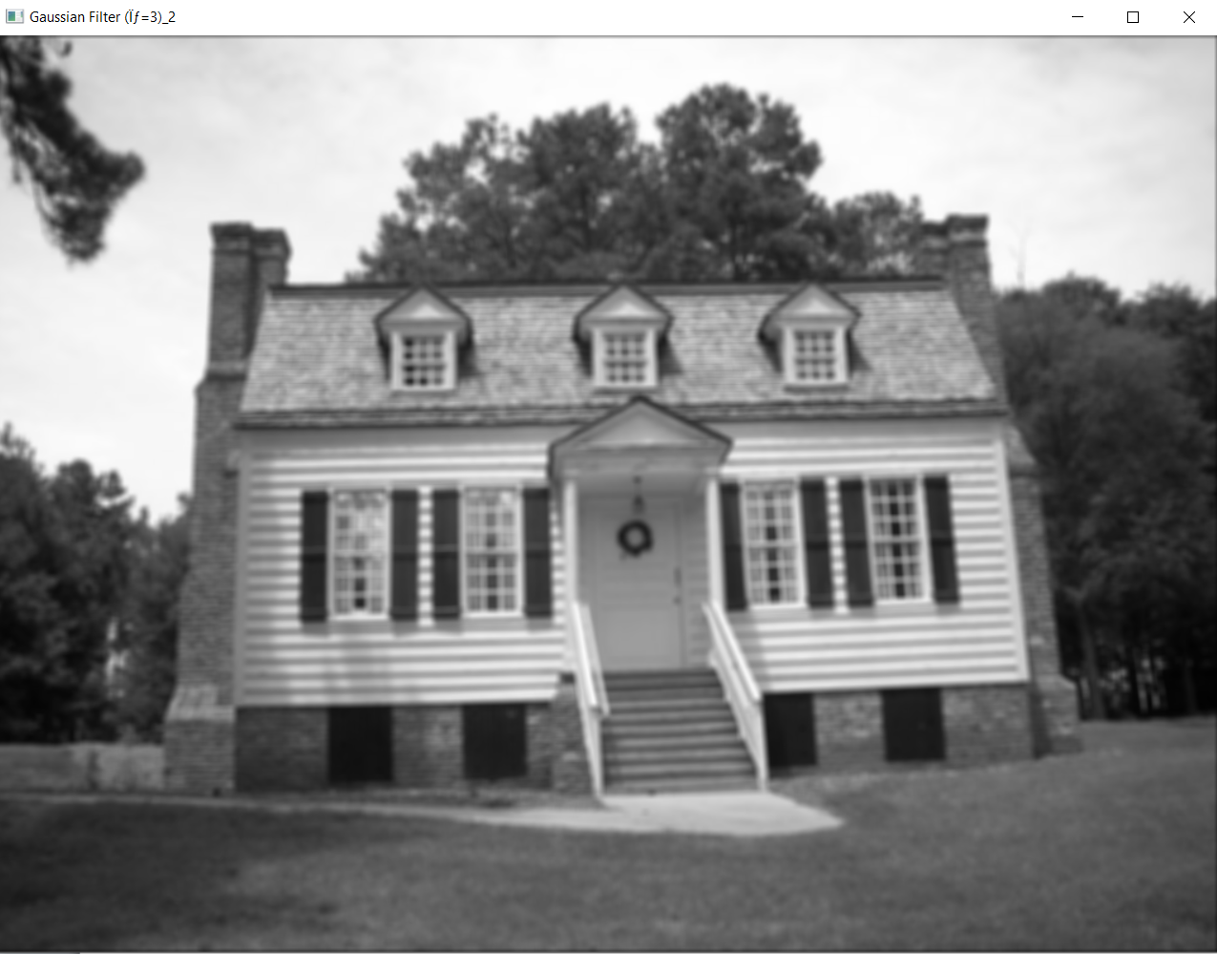

**Part3_House 1 and 2 Sobel Edge Operators:**

**Note: For sobel and after convolution the x and y kernels I take the square root of the square values of x and y:**

**For House1:**

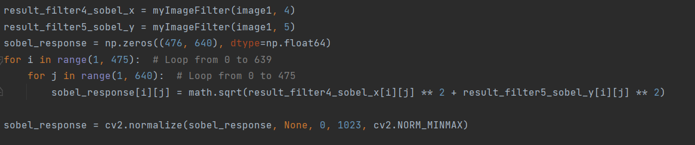

**For House2:**

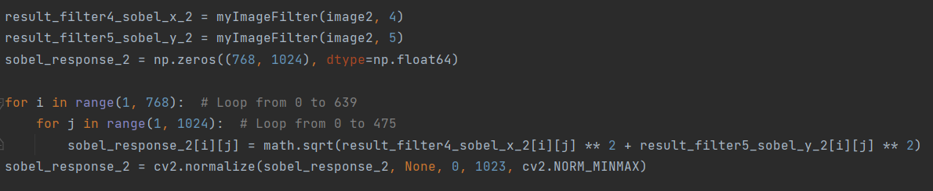

**Output:**

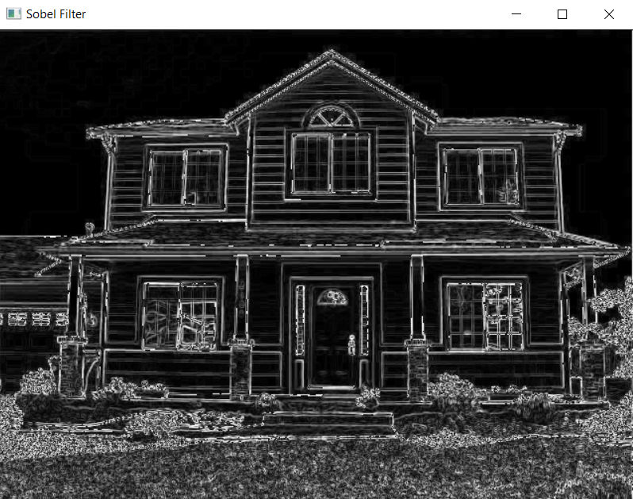

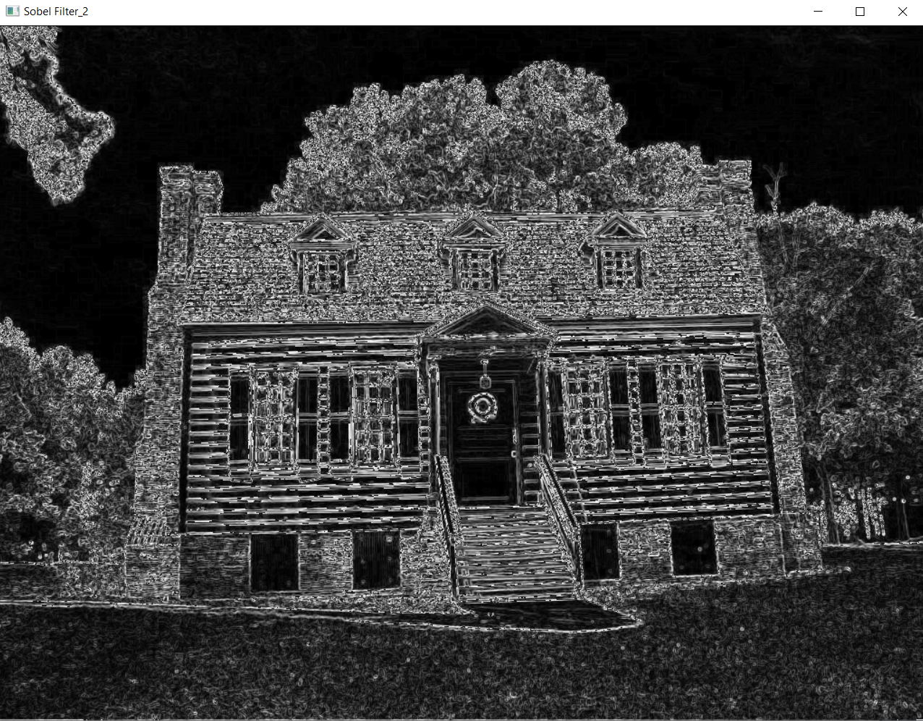

**As we see that sobel detect the edges and highlights the edges in the image by computing the gradient magnitude, emphasizing areas of rapid intensity change.**

**Part4_House1 and 2_ Prewitt Edge Operators:**

**Note: For prewitt and after convolution the x and y kernels I take the square root of the square values of x and y as we see in above part.**

**The output:**

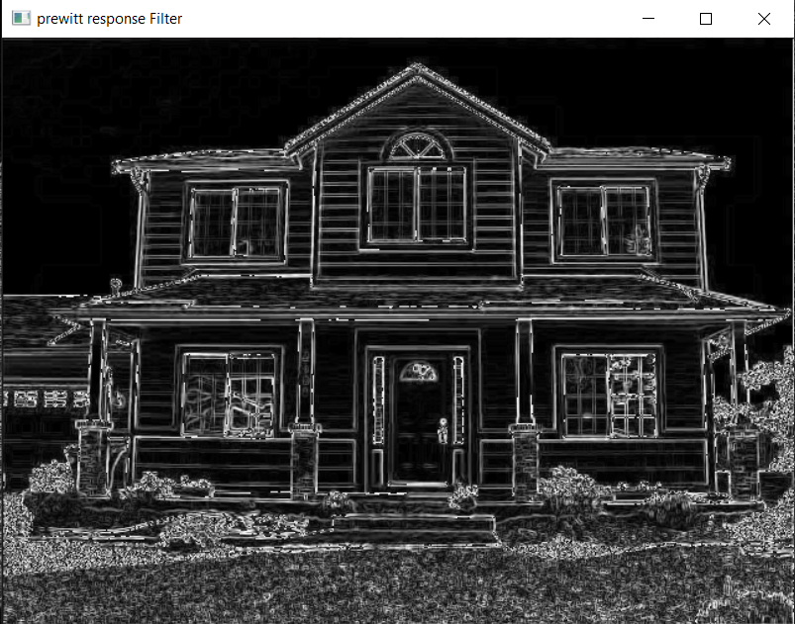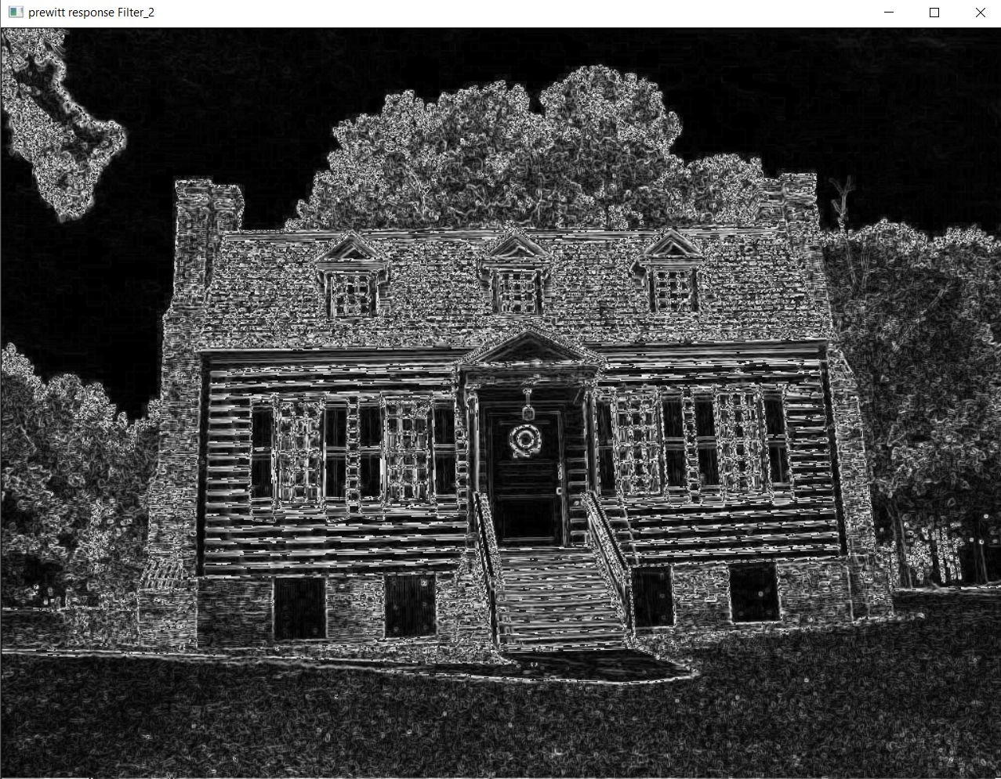

**As we see the difference between Prewitt and Sobel operators lies in their convolution kernels; while both are used for edge detection, Sobel emphasizes diagonal edges more, and Prewitt treats all directions equally.**

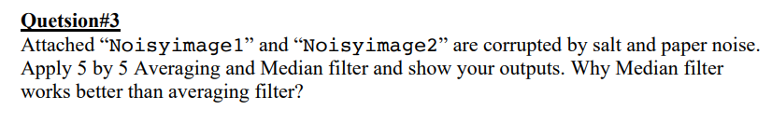

**The code:**

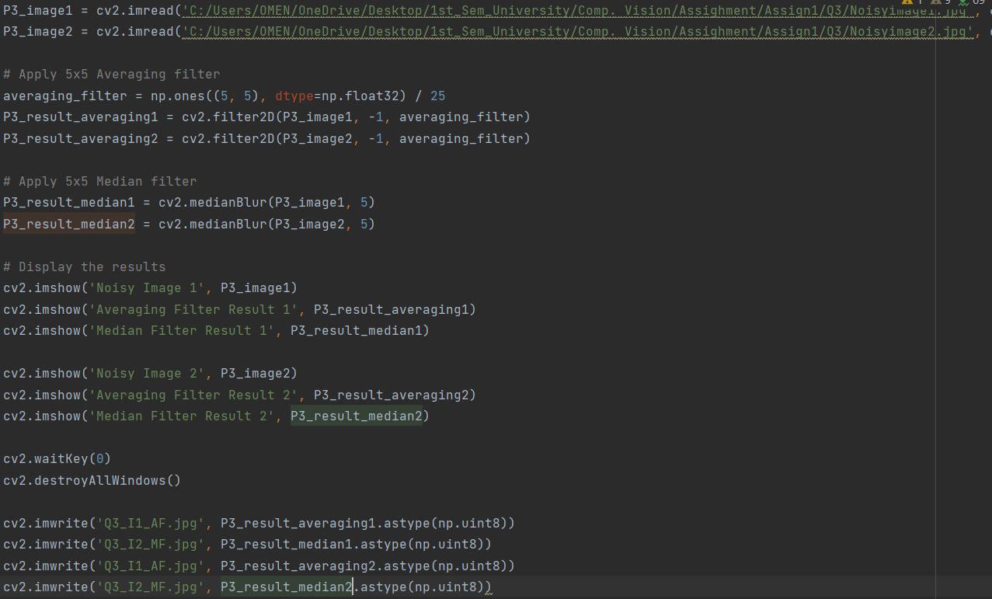

**As we see that the Avariging filter make A 5x5 matrix of ones divided by 25, representing the averaging filter kernel.**

**And the median use this function “cv2.medianBlur(P3_image1, 5).**

**Output ( Image 1):**

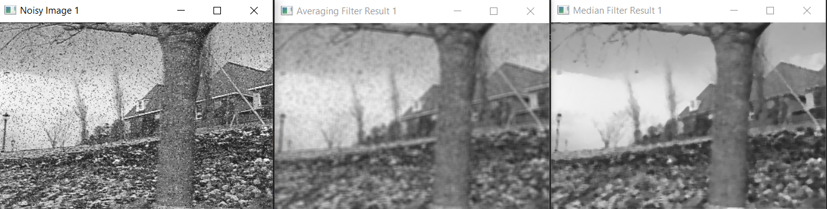

**Output ( Image 2):**

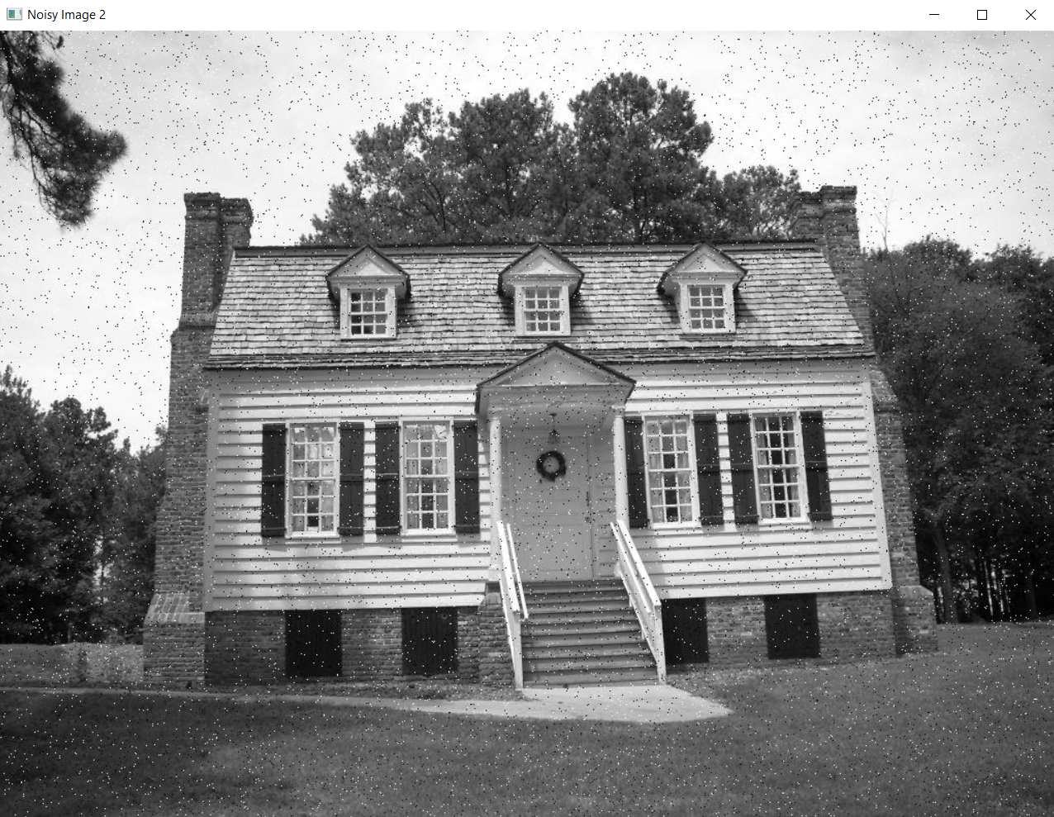 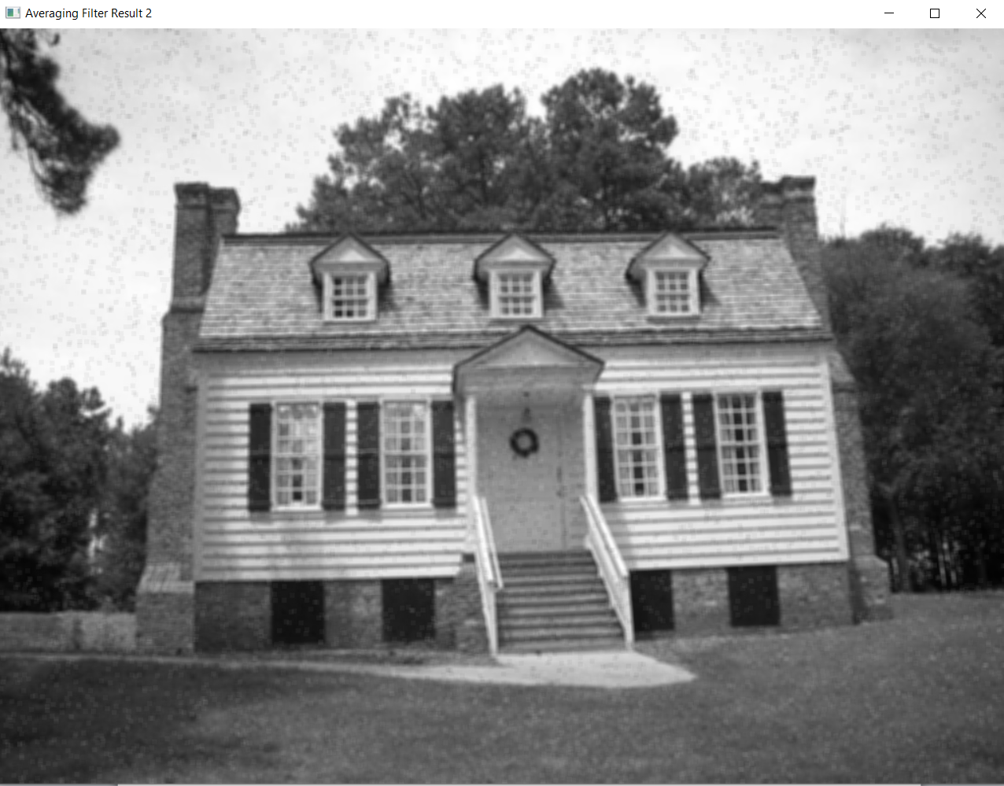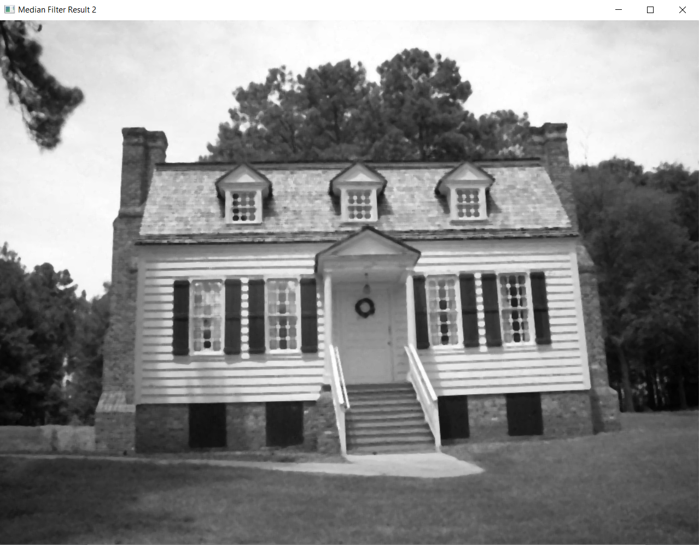

* **As we see** **Median filter works better than averaging filter because it replaces each pixel with the median value of its neighborhood, making it robust to outliers. In contrast, Averaging filter computes the mean, which can be heavily influenced by extreme values introduced by salt-and-pepper noise, resulting in less accurate noise reduction.**

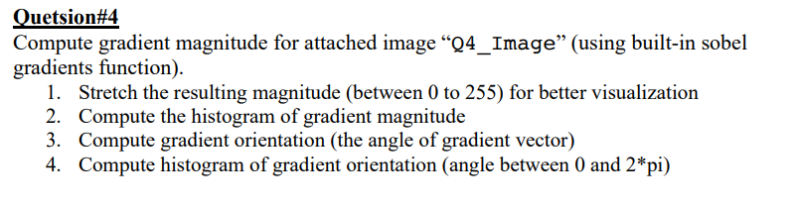

**The Code:**

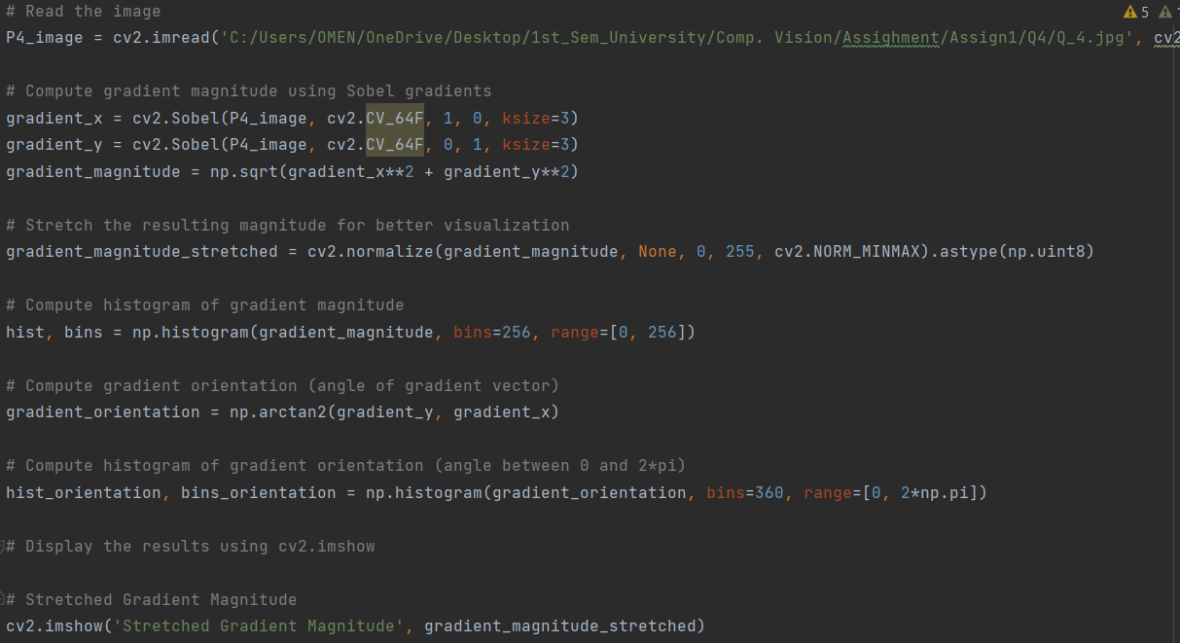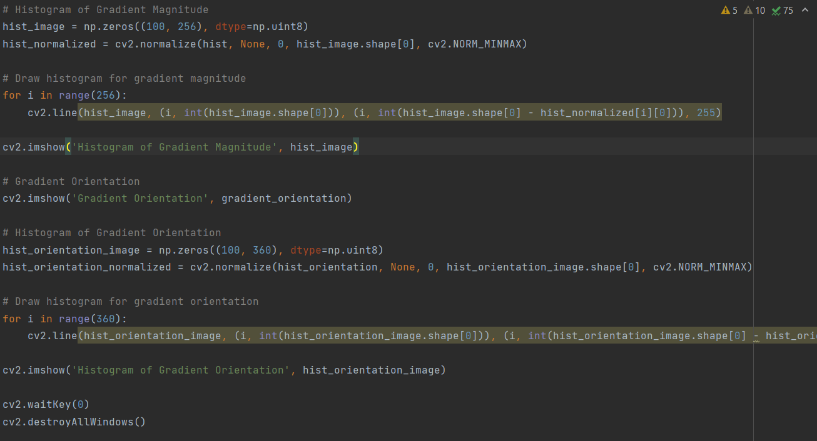

* I explain the code by the comments

**The Output:**

1. **Stretch the resulting magnitude (between 0 to 255) for better visualization:**

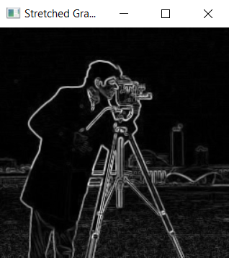

1. **Compute the histogram of gradient magnitude**

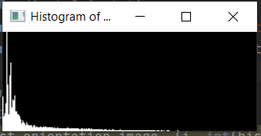

1. **Compute gradient orientation (the angle of gradient vector)** 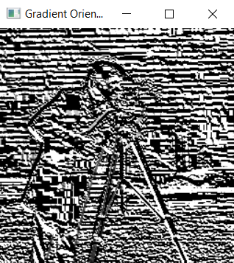
2. **Compute histogram of gradient orientation (angle between 0 and 2*pi)**

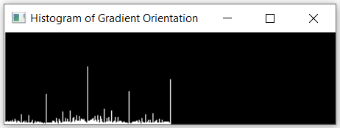

**What The Steps Do?**

1. **Stretching the gradient magnitude enhances visual contrast for better edge perception.**
2. **Histogram of gradient magnitude reveals the distribution of edge strengths in the image.**
3. **Gradient orientation and its histogram provide insights into the predominant directions of edges.**

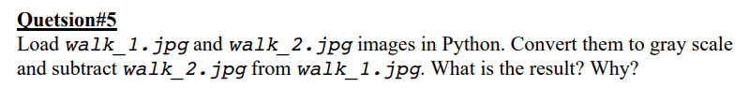

**The code:**

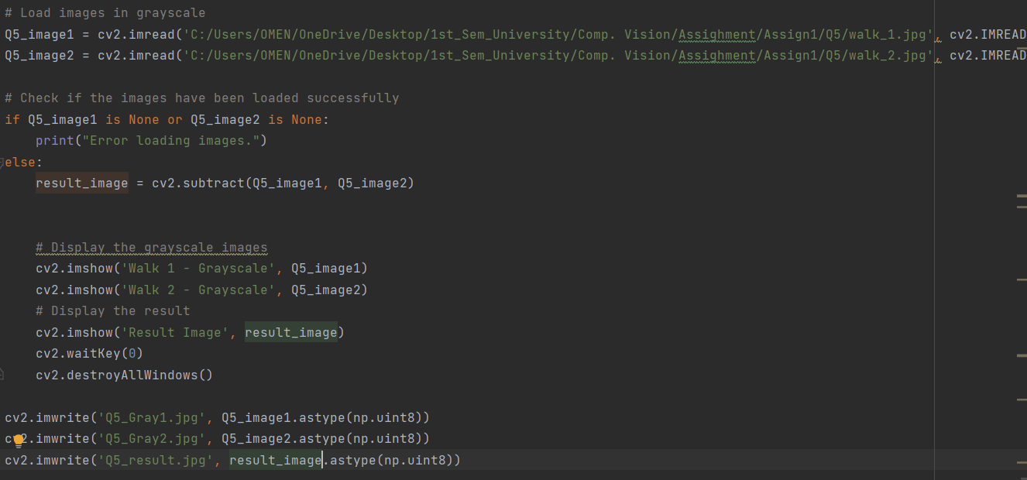

* **I load the images with gray level scale.**
* **And I subtract walk_2.jpg from walk_1.jpg**

**The output:**

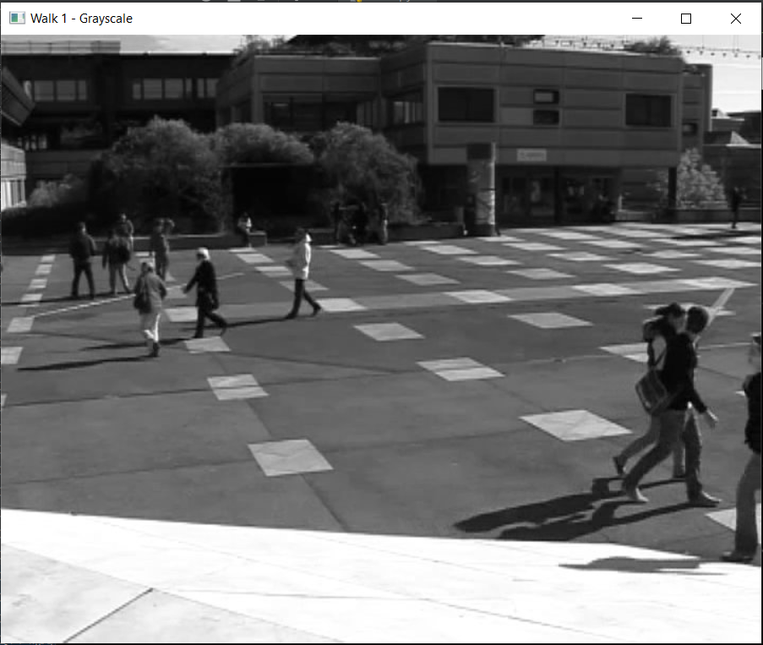 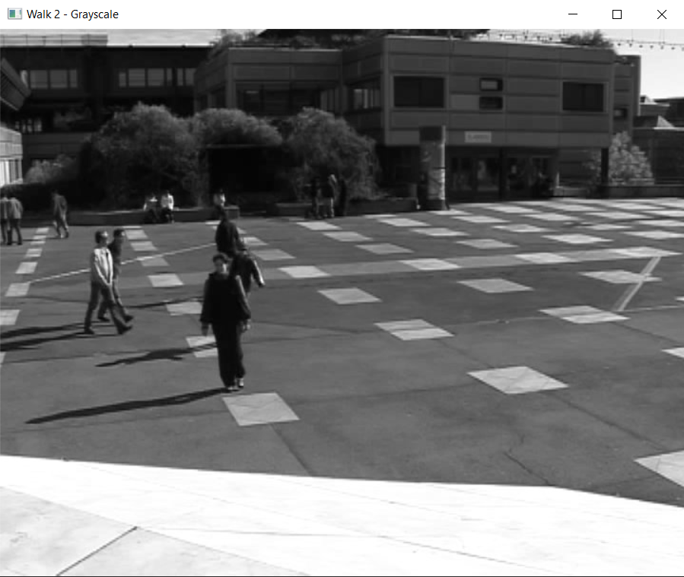

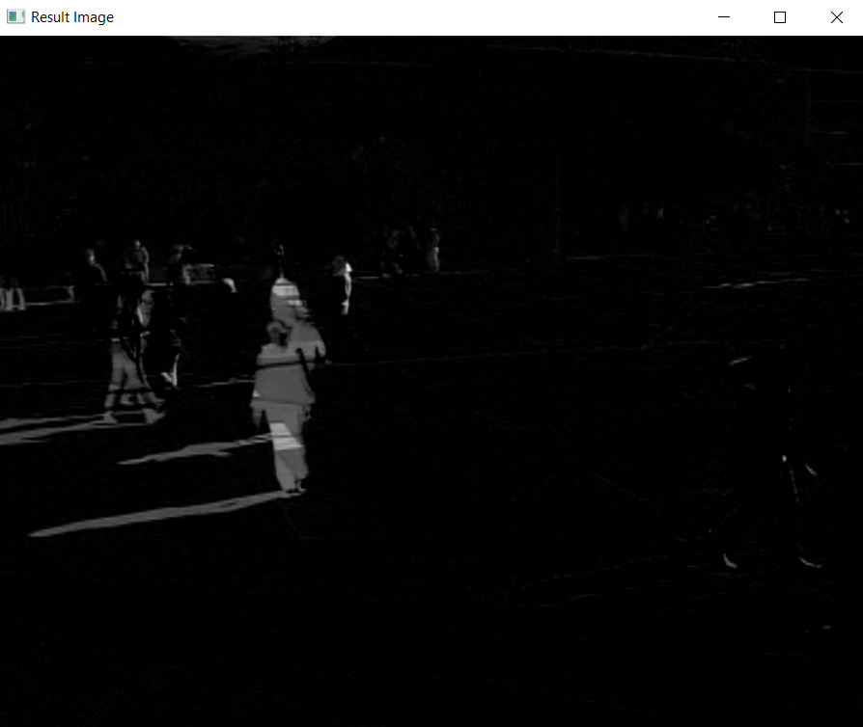

* **We see in the result image the difference between the image walk_1 and walk_2 and when I subtract them every pixels have the same value will remove and the different pixels will still.**

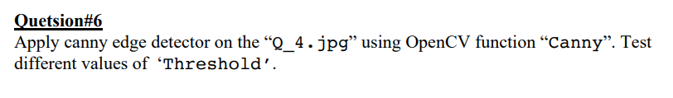

The code:

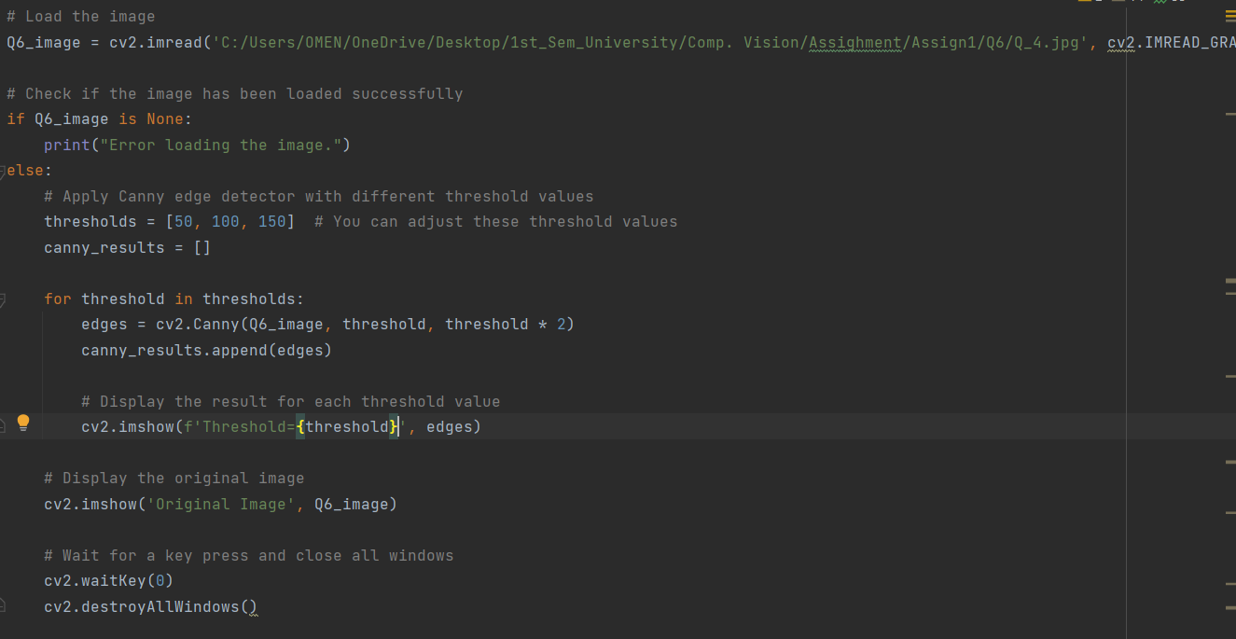

* **We see direct apply to canny with different thresh. Values [50, 100 , 150].**

**The output:**

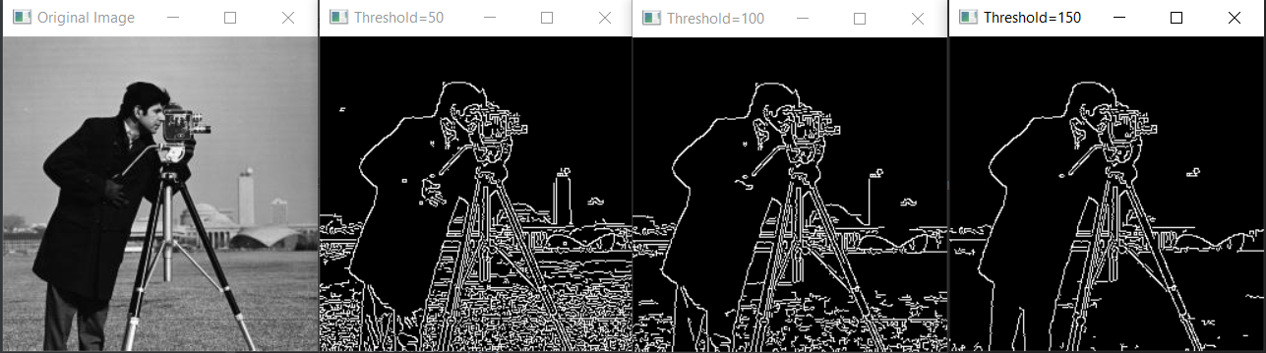

* **As we see the low and high thresholds allows you to control the sensitivity of the edge detector. Higher thresholds result in fewer, but more confident, detected edges, while lower thresholds yield more edges, including weaker ones.**